1.A) Feeds, Collateral Cash

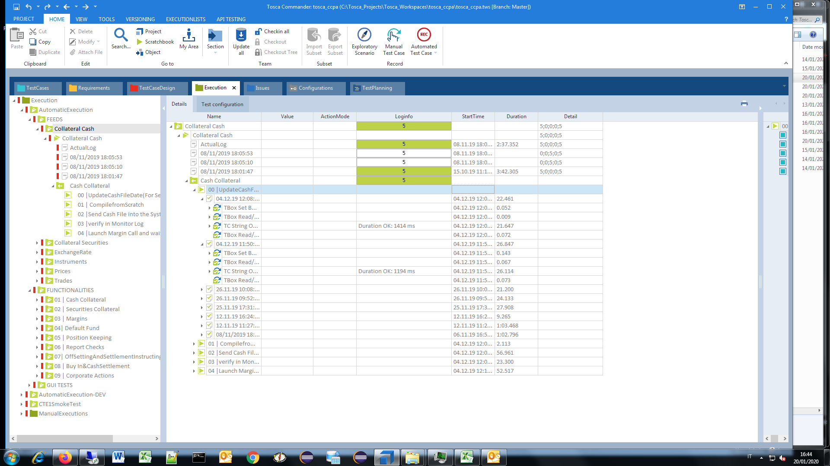

1.B) Collateral Cash, Cash Collateral, Send Cash File into the System.

- Target Directory ITE2 Not available.

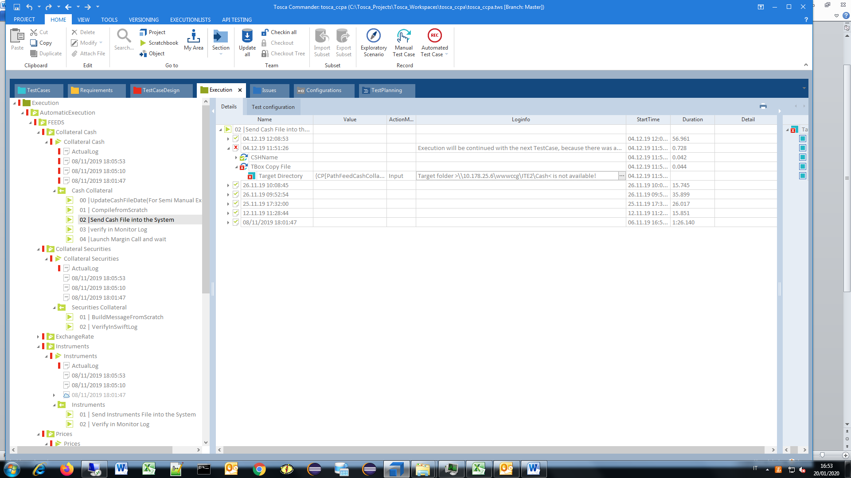

1.C) Collateral Cash, Cash Collateral, Verification fields failed - Different values (1) .

Verification has failed.

Expected value == "CASH000"

Actual value: "CHK-03"

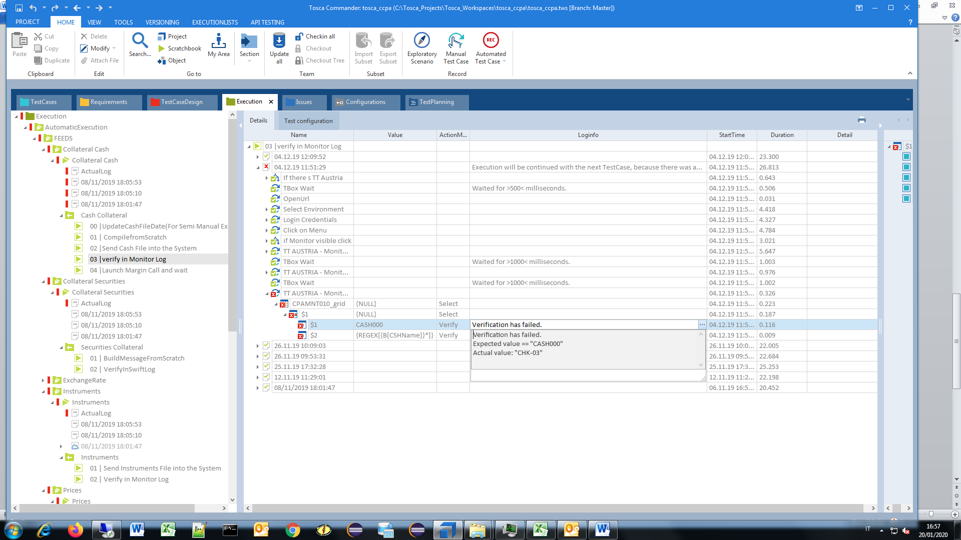

1.D) Collateral Cash, Cash Collateral, Verification fields failed-Different values (2) .

Verification has failed.

Expression: "== CSH191204_115127.txt*"

Actual value: "WARNING!!! CHK-03 Check of Cash Collateral /Security Collateral"

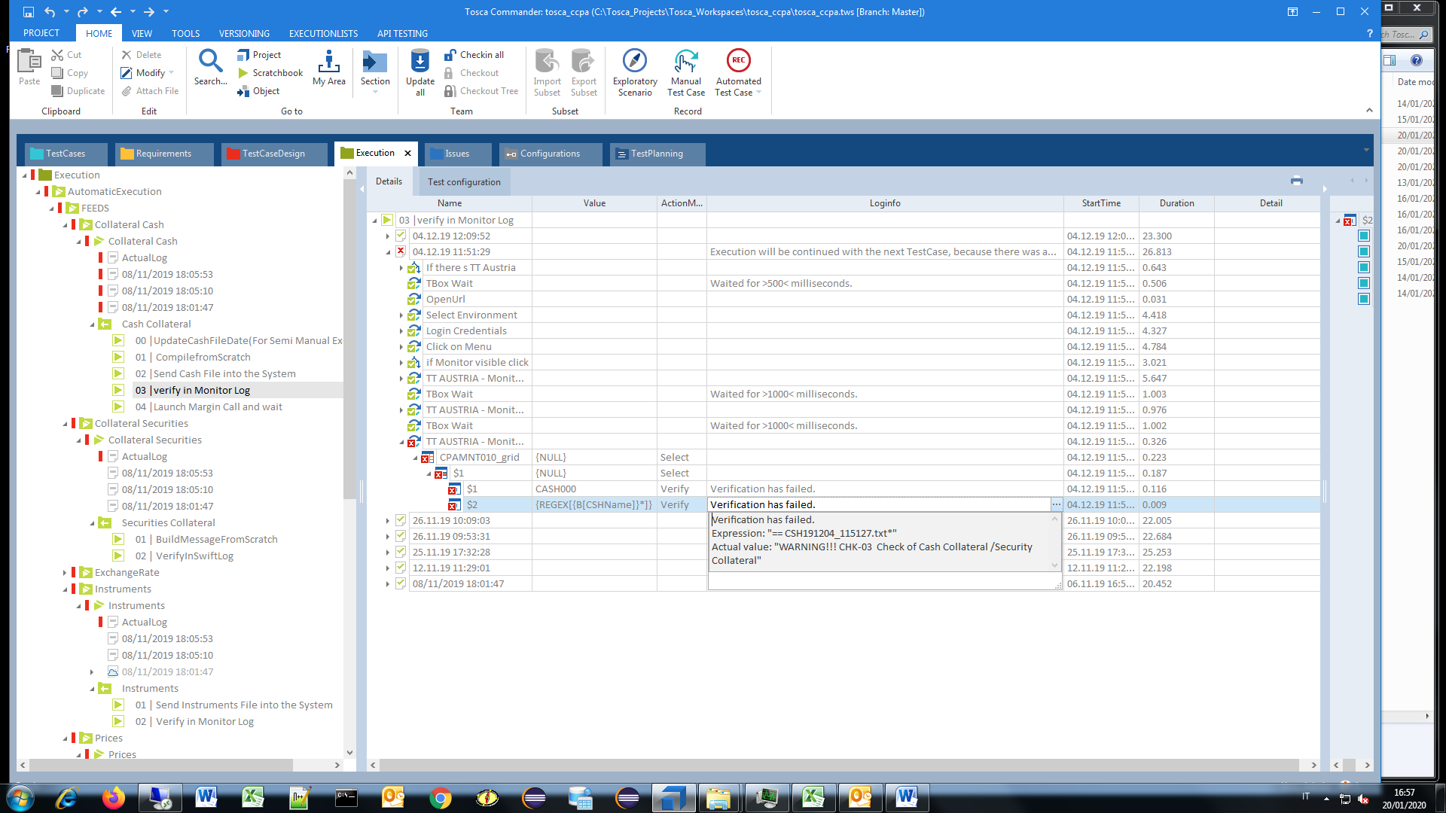

2.A) Collateral Securities, BuildMessageFromScratch, TBox Wait.

- System Threading ... ??? Sentire Quence !

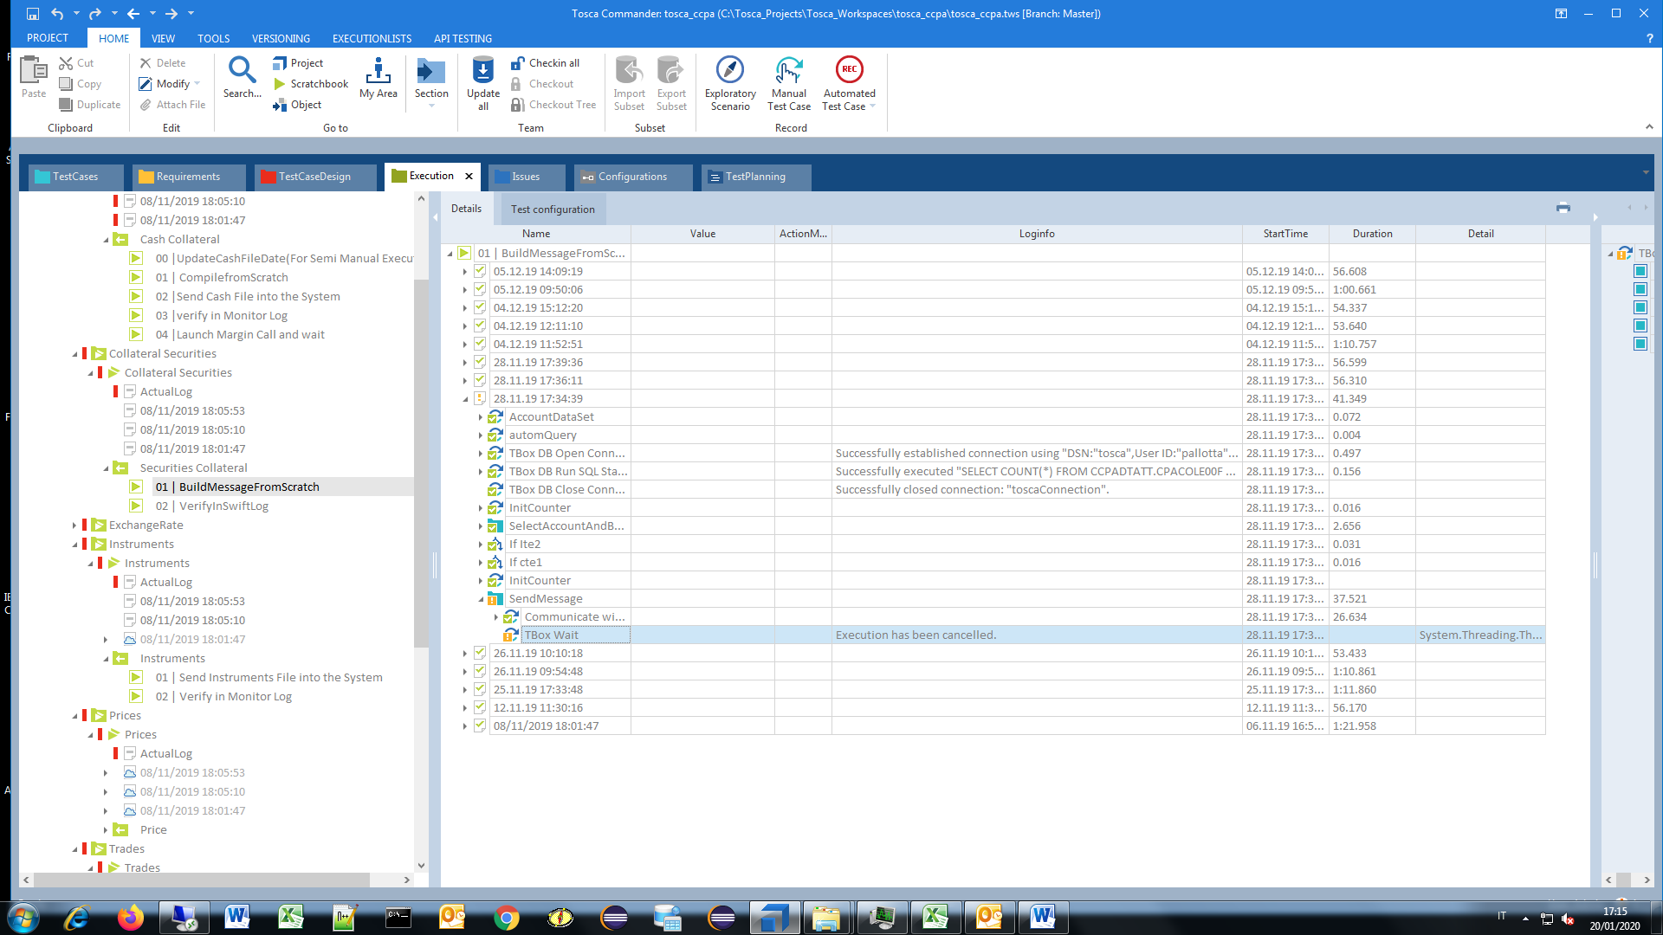

2.B) Collateral Securities, Securities Collateral, VerifyInSwiftLog.

- CPASCHKW10_grid,

Verification has failed.

Expected value == "P"

Actual value: "R"

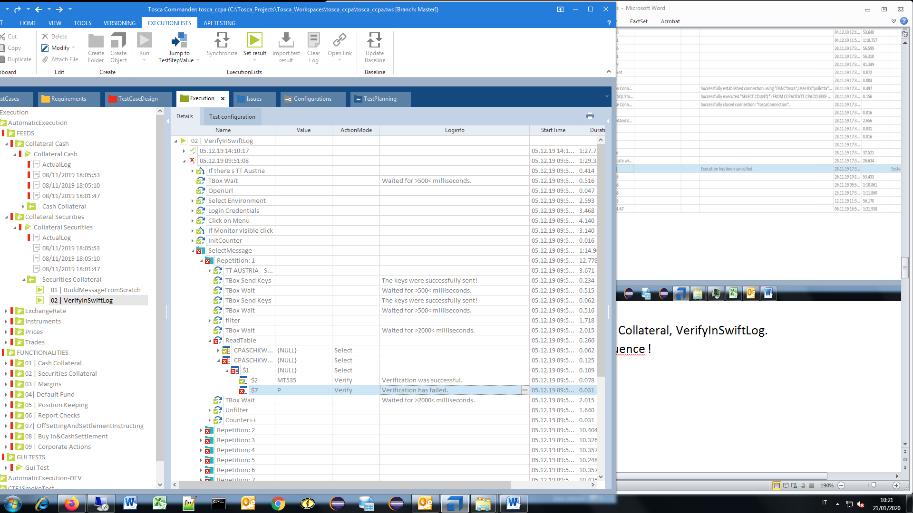

3.A) Exchange Rate, UpdateExchangeRateFile

ERROR [42S02] [Microsoft][ODBC Text Driver] The Microsoft Jet database engine could not find the object 'fx_refkurs.csv'. Make sure the object exists and that you spell its name and ERROR [HY000] [Microsoft][ODBC Text Driver] Text file specification field separator matches decimal separator or text delimiter.

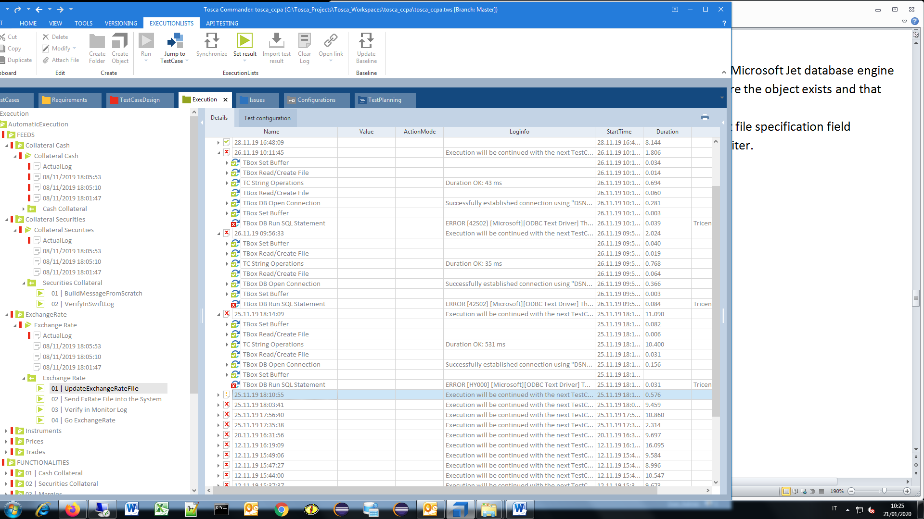

3.B) Exchange Rate, UpdateExchangeRateFile

- SELECT * FROM [fx_refkurs.csv]

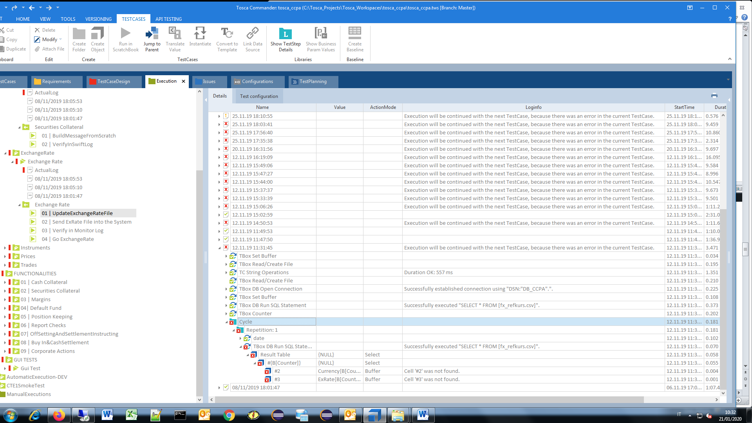

3.C) Exchange Rate, Update Exchange Rate File

ERROR [42S02] [Microsoft][ODBC Text Driver] The Microsoft Jet database engine could not find the object 'fx_refkurs.csv'. Make sure the object exists and that you spell its name and the path name correctly.

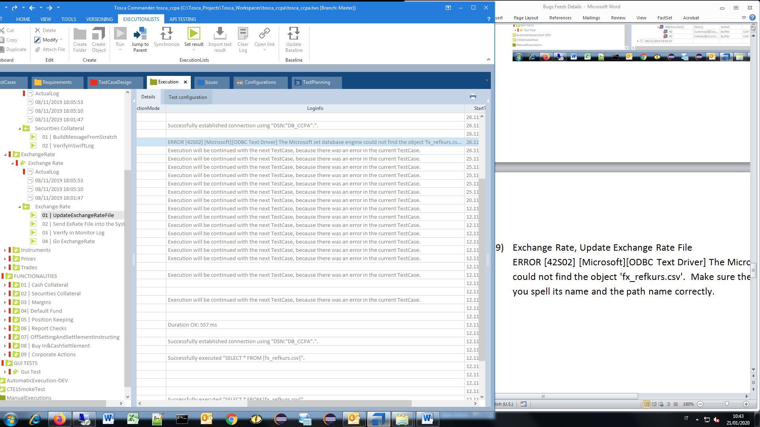

3.D) Exchange Rate, Update Exchange Rate File

- ciclo

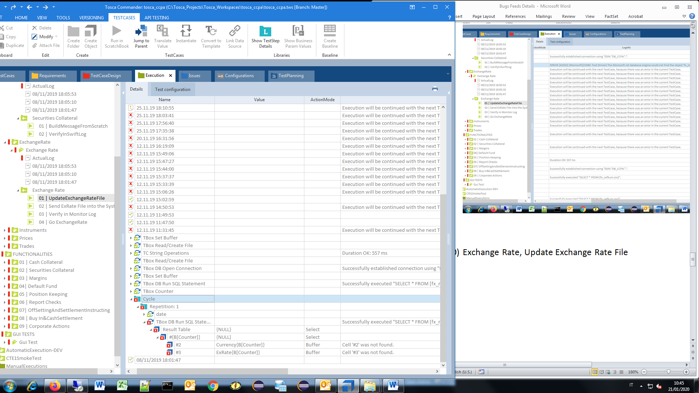

3.E) Exchange Rate, Send ExRate File into System

-Target folder >\\10.178.25.6\wwwccg\ITE2\ExRate< is not available!

- Execution will be continued with the next TestCase, because there was an error in the current TestCase.

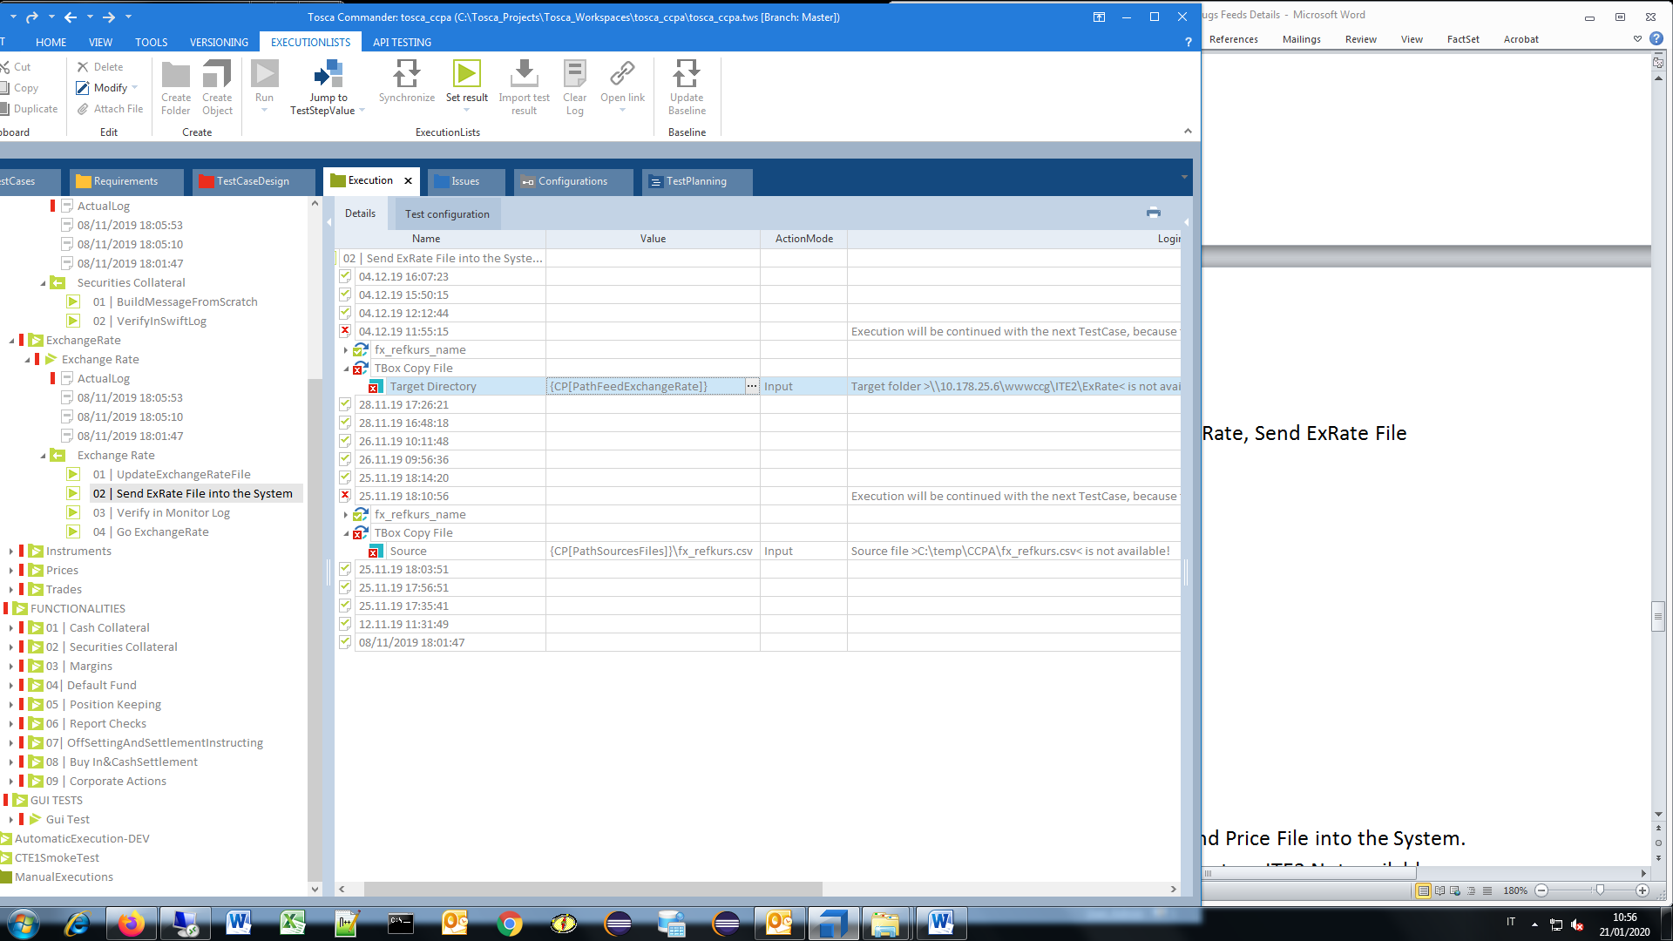

3.F) Exchange Rate, Verify in Monitor Log, TT AUSTRIA – Monitor Log, verification failed

- CPAMNT010_grid

Verification has failed.

Expected value == "XRAT000"

Actual value: "INST000"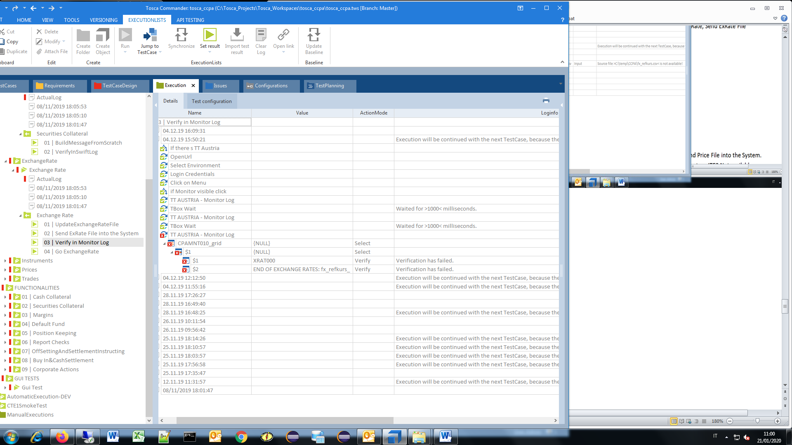

3.G) Exchange Rate, Verify in Monitor Log, TT AUSTRIA – Monitor Log, verification failed, END OF EXCHANGE RATES: fx_refkurs_

Actual Exchange Rate, Verify in Monitor Log, TT AUSTRIA – Monitor Log,

* Login Credentials - More than one matching tab was found.

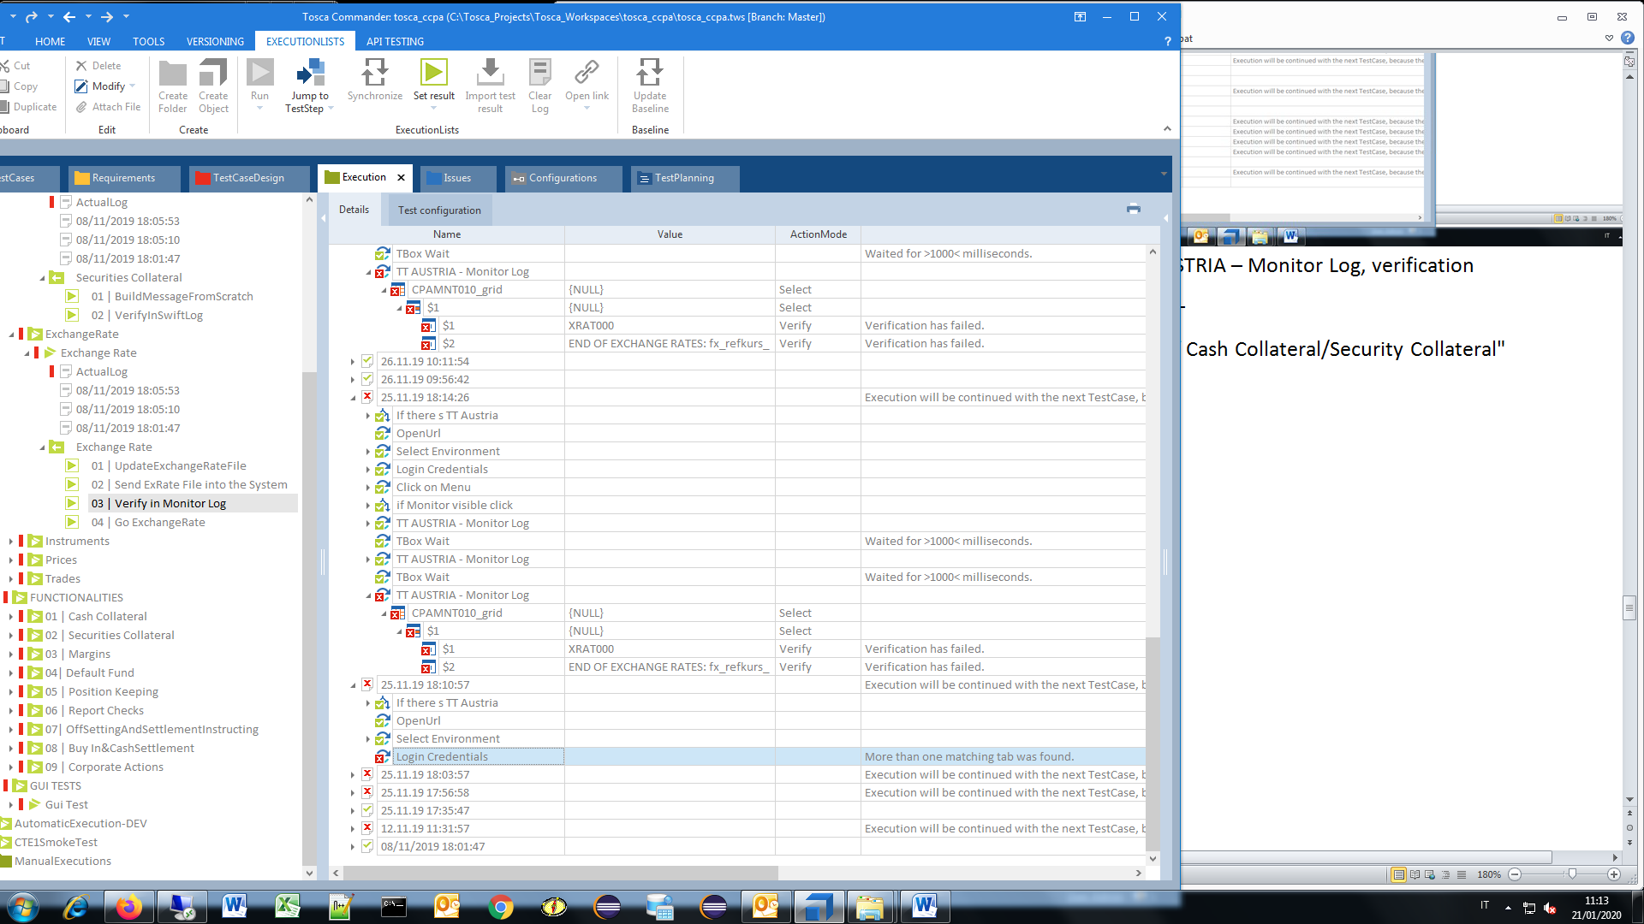

3.H) Exchange Rate, Verify in Monitor Log, TT AUSTRIA – Monitor Log, verification failed.

Expected value == "END OF EXCHANGE RATES: fx_refkurs_"

Actual value: "END OF INSTRUMENTS FILE: instrumentvie20191128.CSV"

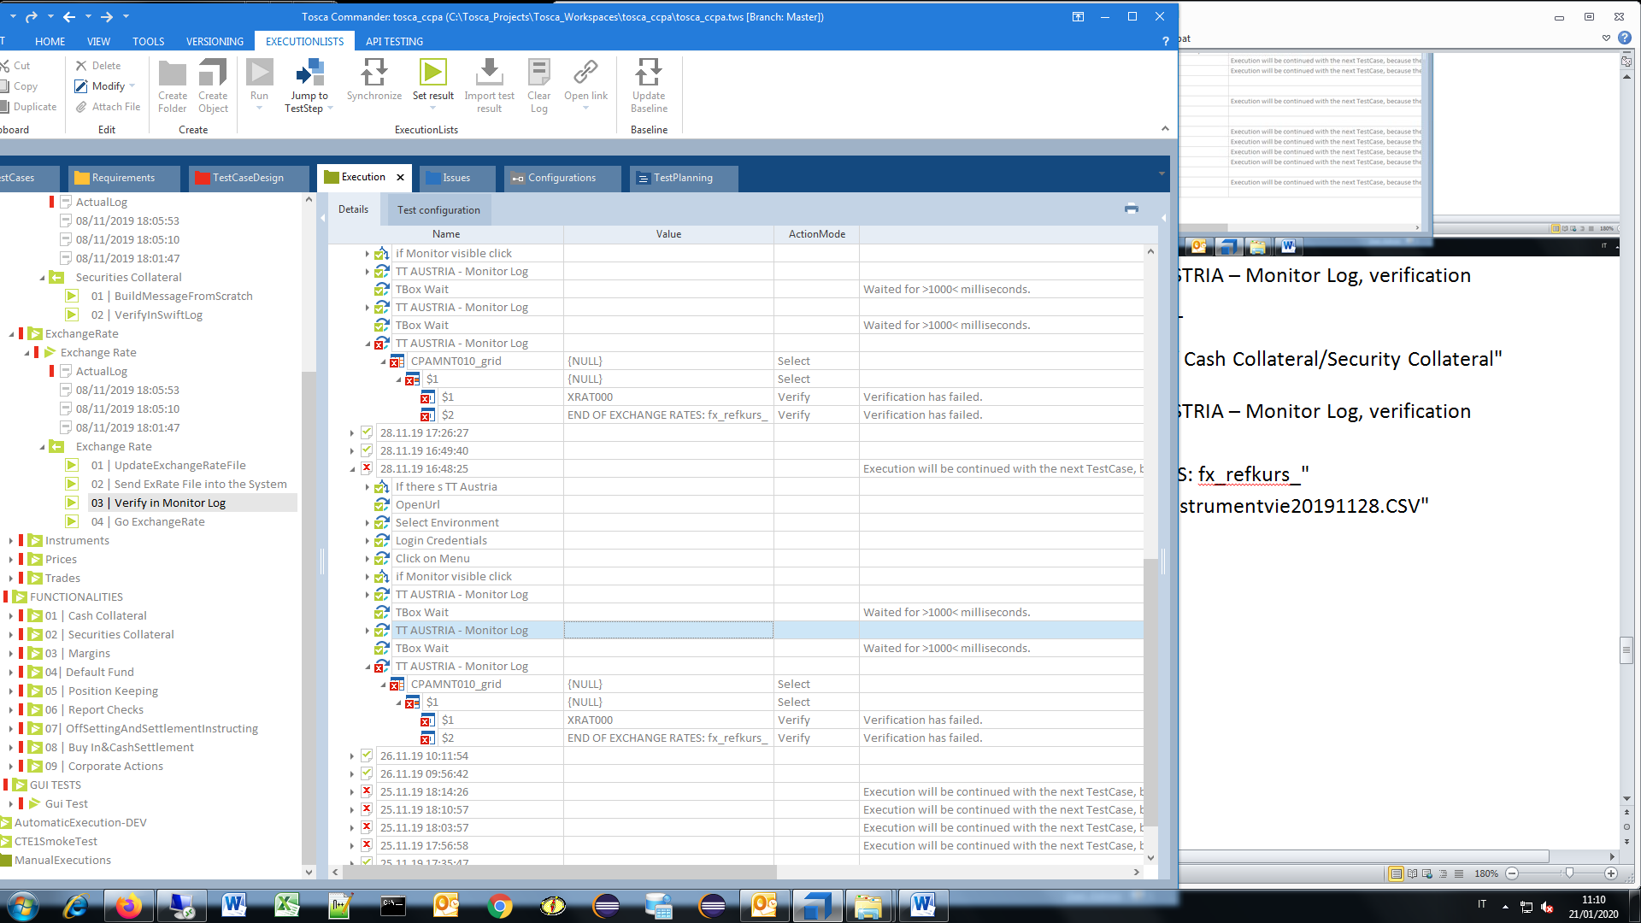

3.I) Exchange Rate, Verify in Monitor Log, TT AUSTRIA – Monitor Log, verification failed.

- Username, password, submit button NOT FOUND - sentire Quence !!!

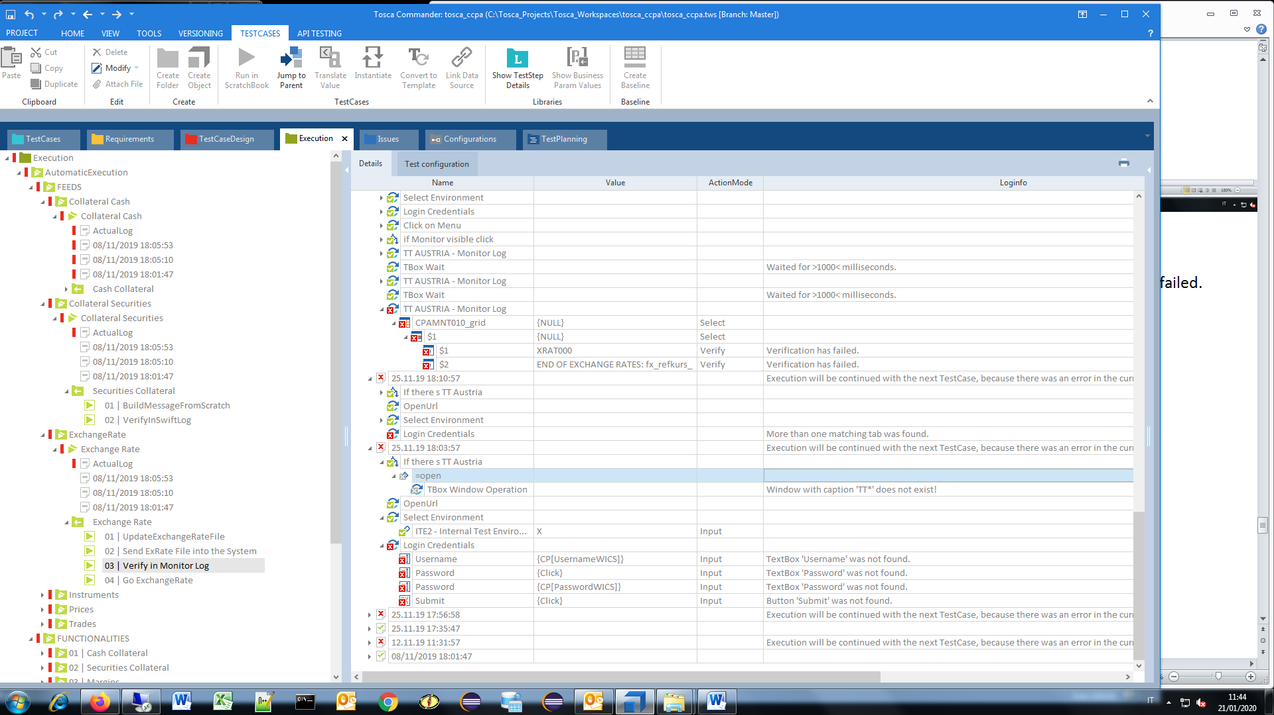

3.M) Exchange Rate, Go ExchangeRate.

- Buffer with name 'CounterExRate' was not found.- sentire Quence !!!

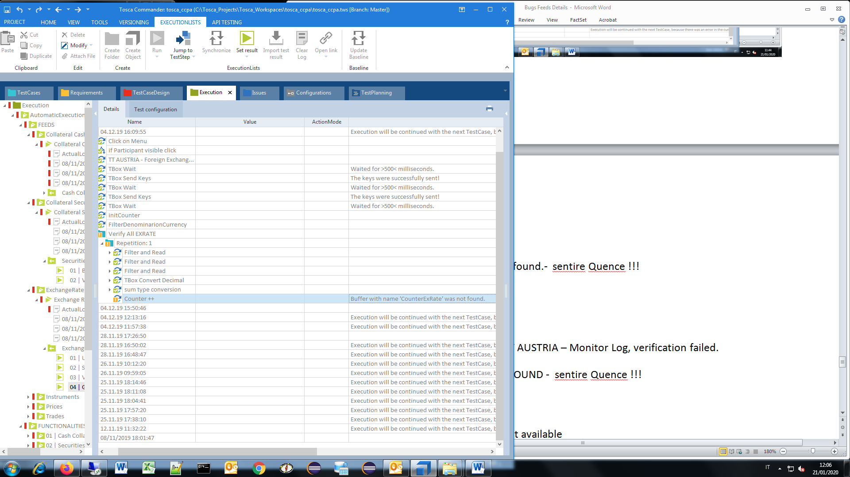

3.M) Exchange Rate, Go ExchangeRate, Execution has been cancelled.

{CALC[{B[ExRateGui]}-{B[ExRate{B[Counter]}]}]}

Buffer with name: "Zero" has been set to value: "-0,03 "

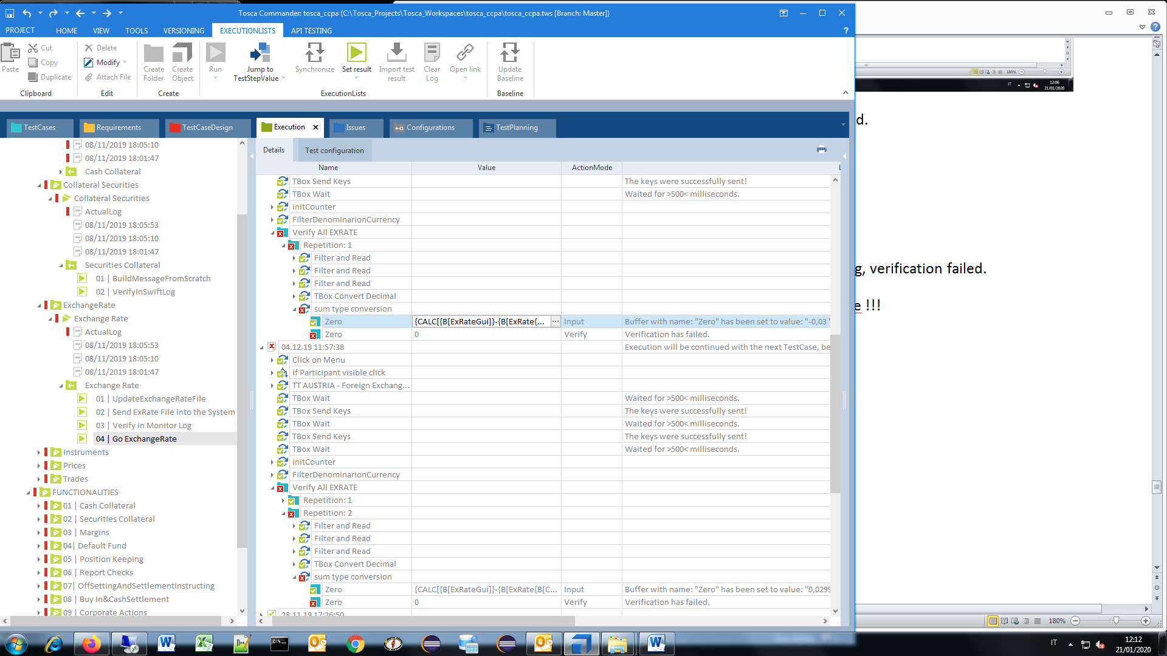

3.N) Exchange Rate, Go ExchangeRate, Execution has been cancelled.

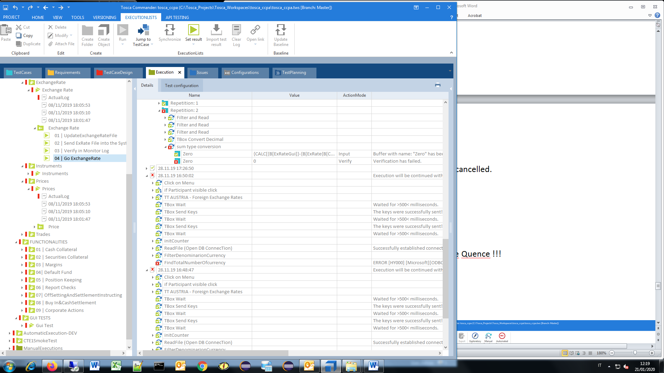

- Username, password, submit button NOT FOUND - sentire Quence !!!